User Guide to finance tele bot



Table of Contents

Users 2

Observer 2

COY/Node 4

Finance Team 7

Troubleshoot 8

# Users

Find **“Finance_1TPT”** on Telegram (refer to Figure 1) and click on Start (refer to Figure 2). Based on your user type, the bot would interact with you differently.

Figure 1: Finance Bot name on Telegram

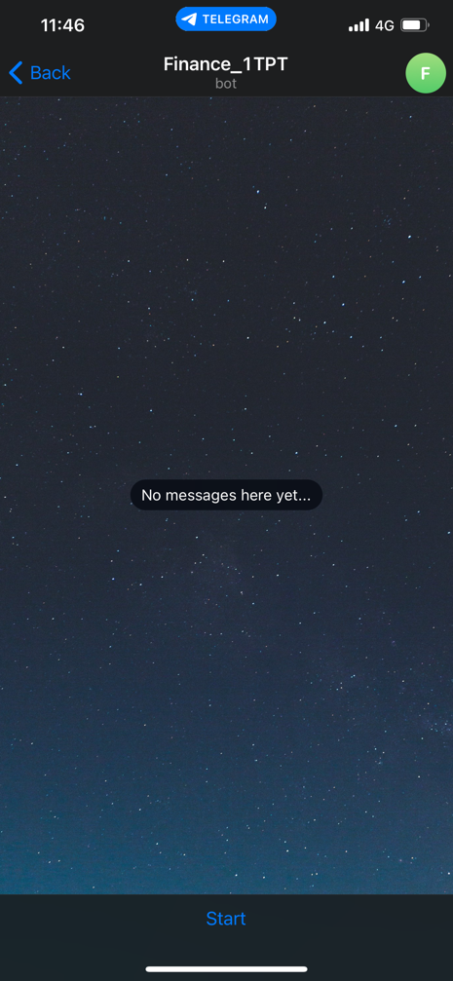

Figure 2: Starting the Finance Bot

If you are:

1. Observer – a casual user that is presented with only metrics of the Purchase Orders
2. COY/Node – point of contact (POC) for any purchases raised for the COY/Nodes. Will see all the Purchase Orders (PO) and the deadlines. Able to send scanned invoices through the bot.
3. Finance Team – Part of S4 Branch Finance

## Observer

Observers are not listed in the bot and can only use the **“/start”** to view the consolidated summary (refer to Figure 3) or to refresh the figures. Alternatively, you can use the ‘Menu’ button located at the bottom left of the chat (refer to Figure 3) to do the same action after the first time.

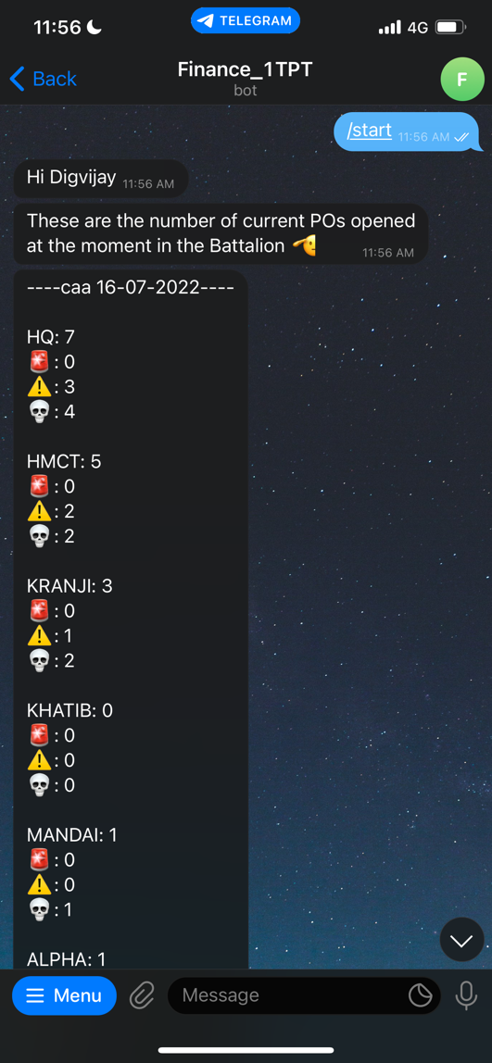

Menu Button

Consolidated summary

/start command used on bot

Figure 3: Observer’s view of the Finance Bot

The consolidated summary shows the total number of PO raised by a coy followed by the urgency of needing to close the PO before late Good Receipt (GR) which is represented by the emojis.

Emojis and what they mean:

* No emoji 🡪 deadline to hand up is more than 10 days away
* 🚨 🡪 deadline is 10 to 7 days away
* ⚠️ 🡪 deadline is 6 to 1 day(s) away
* 💀 🡪 late GR, exceeded the deadline

## COY/Node

POC from all the COY/Nodes in 1 TPT needs to inform S4 Branch Finance Team to be added inside the list in the bot to enable more PO details and the feature of sending the scanned document through the bot.

POC can use **“/start”** to view their PO and **“/send_invoice”** to send the scanned document of the invoice they receive (refer to Figure 4).

Button to send the scanned invoice through the bot

Menu Button to access the same commands without typing

PO Details with the Deadlines

Consolidated summary

/start command used on bot

Figure 4: COY/Node’s view of when starting the bot

The PO comes with a classification of how close it is to being late using emojis (refer to Figure 4).

Emojis and what they mean:

* No emoji 🡪 deadline to hand up is more than 10 days away
* 🚨 🡪 deadline is 10 to 7 days away
* ⚠️ 🡪 deadline is 6 to 1 day(s) away
* 💀 🡪 late GR, exceeded the deadline

To send a scanned document through the bot, the following requirements need to be met:

1. Naming format, PO number and the date when the invoice was received
2. The file is in PDF format (.pdf)

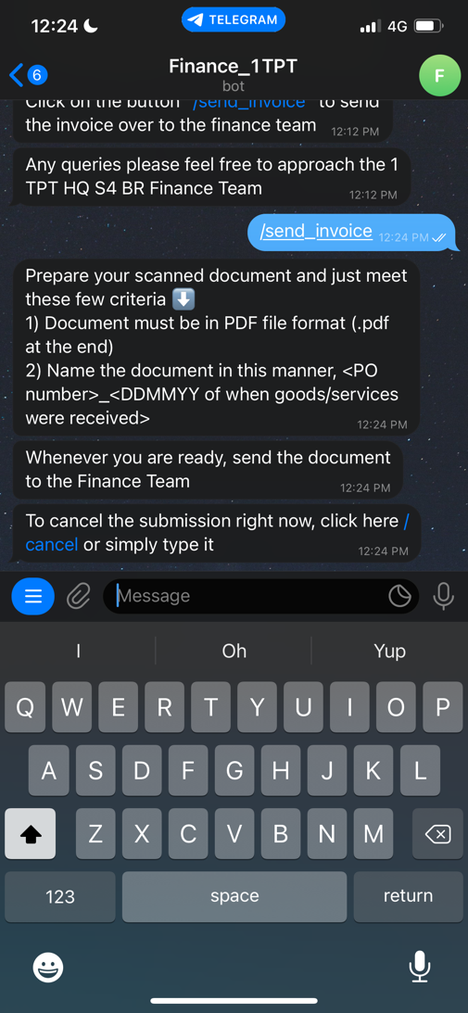

Figure 5: Sending invoice through Finance Bot

Failure to meet these two requirements, the bot would reject the document and ask you to try again (refer to Figure 6).

Figure 6: Example when the wrong PO is entered

When the document is received by the Finance bot, the bot would send a series of messages that the invoice is sent to the Finance team and the deadline to hand up the PO is extended by 14 days (refer to Figure 7).

Figure 7: Successful invoice submission through Finance Bot

To cancel the invoice submission, simply type “/cancel” to cancel the process of submission or click on the message to cancel (refer to Figure 8).

Figure 8: Cancelling the invoice submission process

POC will also get reminders from the bot when the finance team sends them out. This is to look through your PO and ensure that no PO exceeds your deadline to prevent late GR.

Please take note that COY/Nodes cannot other features of the bot from the Menu Button and would be rejected when clicked on.

## Finance Team

The finance team can control the PO displayed on the bot, users on the bot, and send out reminders. To access these features, the Menu button lists all the features in the Finance Bot (refer to Figure 9).

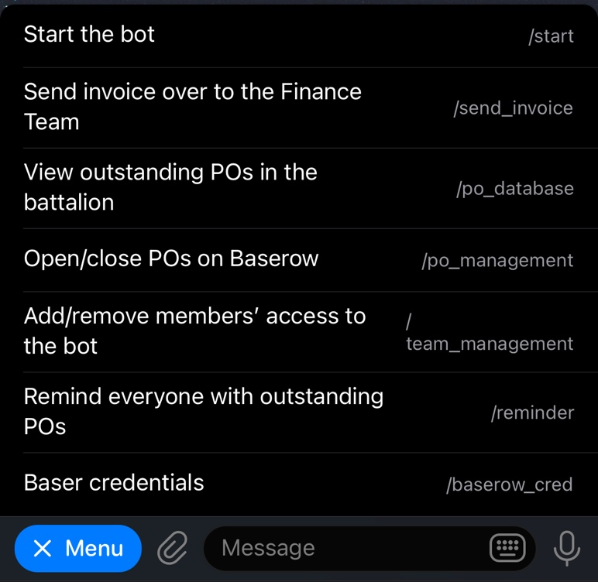

Figure 9: Menu Options for Finance Team

List of actions that can be done:

1. Reminder: the bot sends out a list of PO and their deadlines to the various POCs when the Finance Team clicks on the "/reminder" button on the bot.
2. Receiving Invoice: the bot receives invoices in PDF format and records them down on Baserow. Simultaneously, the bot sends out the invoices to the Finance Team as a reminder to them to start the GR process
3. PO Management – Finance Team can add, close, and extend deadlines for PO on the bot
4. PO Database – bot gives information of the PO of the other coy and node to help in tracking any late GR
5. Team Management – granting access to the bot depending on the user type

Most of these features and how to do them would be on the bot with minimal typing.

Things to take note of:

* When a new PO comes out on NGPS, add the PO on the bot using PO Management
* When the PO has been GR and the hardcopy is received, the PO can be closed on the bot using PO Management
* When a V2 is raised follow these steps:

1. Close the PO on the bot first
2. Add the same PO number without “_V2”
3. Add V2 at the end of the title without any “_” or special characters

To extract the information of the PO in Excel, go on to Baserow.com using the username and password in the bot under “/baserow_cred”. Go to Purchase Orders (PO) and PO table to view and extract the PO if needed.

# Troubleshoot

If the Finance bot types for too long and disappears, in most cases, means that the user input is not correct, and unrecognizable to the Finance bot.

* Follow the same format as suggested by the Finance bot
* Inform this bug the programmer to settle it

In most cases, if there are any errors, the Finance bot would send out an error code which can be copied and sent to the programmer to solve the error.